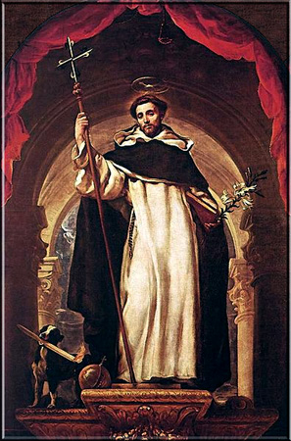
Prayer in Honor of St. Dominic
My Lord Jesus Christ, who didst found Thy Church with Thy Most Precious Blood and, by the preaching of the Apostles, didst establish it, propagate it and extend it throughout the whole world; and after them didst send the holy Patriarch Dominic to adorn it, enlighten it and defend it by the splendor of his merits and doctrine; vouchsafe to hear the prayers incessantly offered by that apostolic man for the increase of the spiritual goods and the temporal welfare of the same Thy Church.
Our Father, Hail Mary, Glory be.
Most merciful Redeemer, who didst choose Saint Dominic to labor with Thee in the saving of souls, and he, by his zeal and Thy grace, won over to the Church so many heretics who were separated from her, and so many sinners who had grieved her by their evil lives; O my God, do thou send new laborers always into Thy vineyard to work for Thy glory and to gather in the fruits of everlasting life.
Our Father, Hail Mary, Glory be.
O good Jesus, who didst delight to see Saint Dominic kneeling every night before Thine altar, adoring Thee hidden in the Blessed Sacrament with lively faith and offering in turn groans, prayers and penances in behalf of the Church, at that time persecuted by her enemies and profaned by her own children; defend this Thy Spouse through the intercession of Saint Dominic from the insults and the plots of the infernal enemy of mankind.
Our Father, Hail Mary, Glory be.
V. Pray for us, Saint Dominic,
R. That we may be made worthy of the promises of Christ.
Let us pray: Grant, we beseech Thee, Almighty God, that we who are weighed down by the burden of our sins, may be raised up by the patronage of blessed Dominic Thy Confessor. Through Christ our Lord. Amen.
(Indulgence of 300 days once a day)

